TEAM 4
SAMYUKTHA M-23BTT035

1. Ultrasonic Sensor (HC-SR04)
Sensor Type:
Ultrasonic Distance Sensor
Objective:
To determine the distance of an object by using ultrasonic sound waves with Arduino.
Components Required:
- Arduino Uno
- HC-SR04 Ultrasonic Sensor
- Jumper wires
- Laptop with Arduino IDE
Working Principle:
The ultrasonic sensor operates by emitting a sound pulse through the trigger pin. This sound wave travels through the air and reflects back when it encounters an object. The echo pin receives the reflected signal. The Arduino calculates the distance by measuring the time taken for the signal to return.
Arduino Connections:
- VCC → 5V
- GND → GND
- Trig → Pin 9
- Echo → Pin 10
Arduino Program:
const int trigPin = 9;
const int echoPin = 10;
long duration;
int distance;
void setup() {
Serial.begin(9600);
pinMode(trigPin, OUTPUT);
pinMode(echoPin, INPUT);
}
void loop() {
digitalWrite(trigPin, LOW);
delayMicroseconds(2);
digitalWrite(trigPin, HIGH);
delayMicroseconds(10);
digitalWrite(trigPin, LOW);
duration = pulseIn(echoPin, HIGH);
distance = duration * 0.034 / 2;
Serial.print("Distance: ");
Serial.print(distance);
Serial.println(" cm");
delay(500);
}
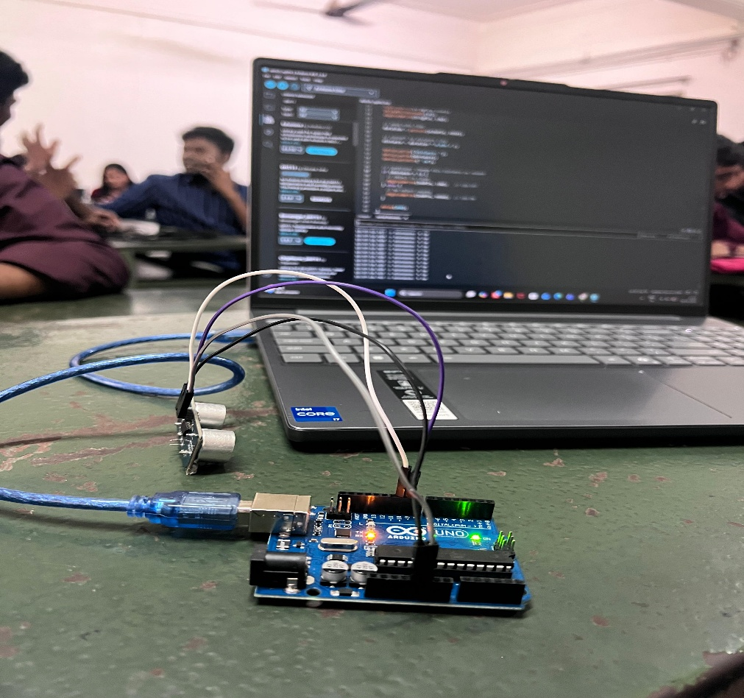

2. Temperature and Humidity Sensor (DHT11)
Sensor Type:
Temperature and Humidity Sensor
Objective:
To monitor and measure environmental temperature and humidity using Arduino.
Components Required:
- Arduino Uno
- DHT11 Sensor
- Jumper wires
- Laptop with Arduino IDE
Working Principle:
The DHT11 sensor uses a thermistor to measure temperature and a capacitive sensor to detect humidity. These values are converted into digital signals and transmitted to the Arduino for processing.
Arduino Connections:
- VCC → 5V
- GND → GND
- DATA → Pin 2
Arduino Program:
#include "DHT.h"
#define DHTPIN 2
#define DHTTYPE DHT11
DHT dht(DHTPIN, DHTTYPE);
void setup() {
Serial.begin(9600);
dht.begin();
}
void loop() {
float humidity = dht.readHumidity();
float temperature = dht.readTemperature();
if (isnan(humidity) || isnan(temperature)) {
Serial.println("Failed to read from DHT sensor");
return;
}
Serial.print("Temperature: ");
Serial.print(temperature);
Serial.print(" °C ");
Serial.print("Humidity: ");
Serial.print(humidity);
Serial.println(" %");
delay(2000);
}
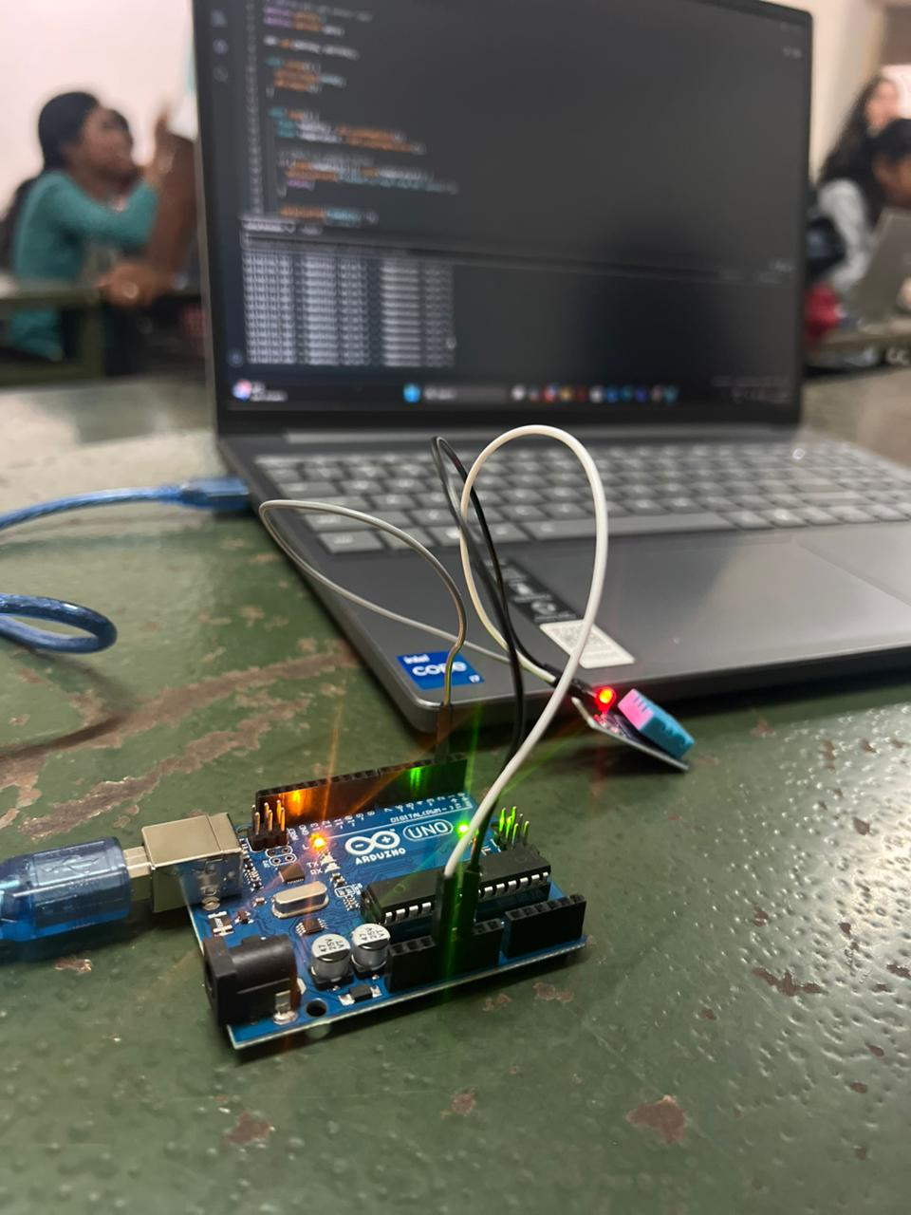

3. IR Sensor for Object Detection
Sensor Type:
Infrared Object Detection Sensor
Objective:
To identify the presence of objects using infrared light with Arduino.
Components Required:
- Arduino Uno
- IR Obstacle Detection Sensor Module
- Jumper wires
- Laptop with Arduino IDE
Working Principle:
The IR sensor includes an infrared transmitter and a receiver. The transmitter emits infrared light continuously. When an object is placed in front of the sensor, the emitted light reflects back and is detected by the receiver. The sensor then sends a signal to the Arduino indicating whether an object is present.
Arduino Connections:
- VCC → 5V
- GND → GND
- OUT → Pin 7
Arduino Program:
int sensorPin = 7;
void setup() {
pinMode(sensorPin, INPUT);
Serial.begin(9600);
}
void loop() {
int objectState = digitalRead(sensorPin);
if(objectState == LOW) {
Serial.println("Object Detected");
} else {
Serial.println("No Object");
}
delay(500);
}
